Vzorový test AJ – 6. ročník

1. Read this text and answer the questions. Use a sentence. (Odpověz celou větou.)
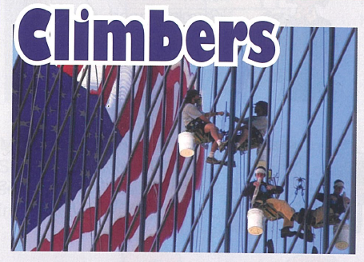
Most people think that climbing is dangerous. There are climbers who climb every day because it is their job. They don´t climb mountains, they climb buildings. Their job is to repair and clean parts of buildings that are difficult to reach. They climb offices, monuments, church towers and chimneys.
When they work, the most important thing is safety. They always work in pairs, never alone. They enjoy their job, it is exciting for them. They would never like a normal job in a warm office.

1. Do the climbers in our text climb mountains?
________________________________________________________________
2. What is their job?
________________________________________________________________
3. What is the most important thing when they work?
________________________________________________________________
4. How do they work?
________________________________________________________________
5. Do climbers like their job?
________________________________________________________________

2. Write the time. Napiš správně čas.
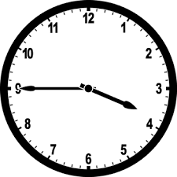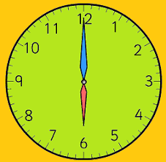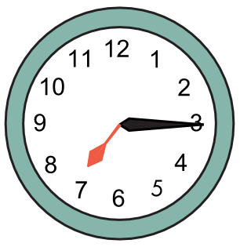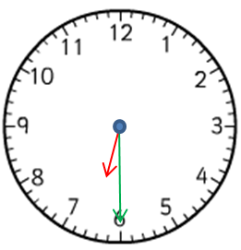

3. Make questions for the underlined words.
- Peter lives in London. ……………………………………………………………………………
- Yes, she can swim. ……………………………………………………………………………
- Tom has got a blue bike. ……………………………………………………………………………
- The lesson starts at nine o’clock. ……………………………………………………………………………
- We go to school by bus. ……………………………………………………………………………
4. Choose the correct word. Vyber správné slovo.
- This is my brother. ………… name is Tom.
a) He b) His c) Him d) He’s
- We have got a cat. ………… eyes are green.
a) It b) It’s c) Its d) It is
- My parents ………… a big house.
a) has got b) have got c) haven’t got d) is got
- I ………… my homework every day.
a) do b) am doing c) does d) doing
- ………… you like ice cream?
a) Are b) Do c) Does d) Is

6. Fill in the preposition. Doplň předložku.
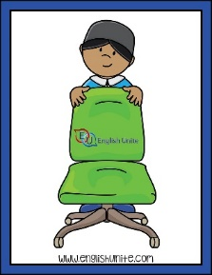 1. The boy is ____________________the chair.
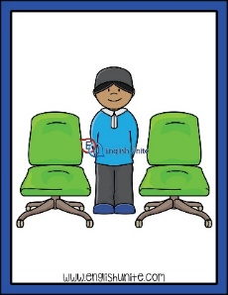 2. The boy is_______________________the chairs.
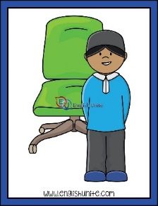 3. The boy is __________________of the chair.
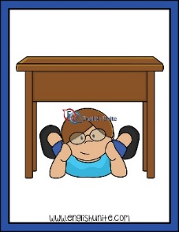 4. The boy is_________________the table.
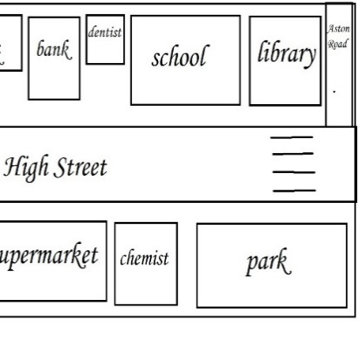 5. The park is _________________the library.

7. Put the words in the correct order . Seřaď slova správně za sebou.
1. speak / teacher / can / Our / Italian
2. Mr. / on / is / Black / football / watching / TV
3. half / go / I / past / to / nine / bed / at.
4. James / film / his / talking / about / is / favourite
5. computer / got / haven´t / parents / His / a

Součástí testu je i poslechové cvičení v rozsahu učiva úrovně A 1.

