Vzorový test AJ – 6. ročník

1. Read the text and answer the questions. Přečti text a odpověz na otázky celou větou.
I´m Peter Smith. I´m from London. I work in a bank. I get up at half past seven. Then I have a shower. I have breakfast in the kitchen at eight o´clock.I like cereal with milk and orange juice. I finish my work at nine p.m. I like sports. I play football and I go swimming in my free time. I have dance class on Fridays, too.

1. When does he get up?
2. Where does he have breakfast?
3. What does he like for breakfast?
4. When does he finish work?
5. What does he do in his free time?

2. Write text with he.

3. Write the time. Napiš správně čas.
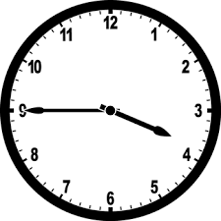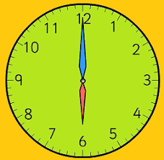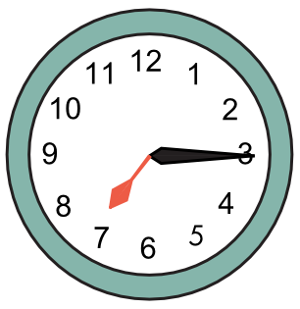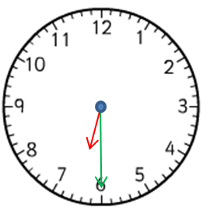

4. . Choose the correct word. Vyber správné slovo.

1. Lucy is a good tennis player. This is …………. racket
a) she´s b) her c) hers d) his
2. Do you like my new pencilcase? …………………. colour is black.
a) It b) It´s c) It is d) Its
3. The parrot …………………..two legs. It lives in a cage.
a) have got b) has got c) hasn´t got d) haven´t got
4) Wait! We …………………………. a cartoon on TV at the moment.
a) are watching b) watching c) watch d) is watching

5. Fill in the preposition. Doplň správnou předložku.

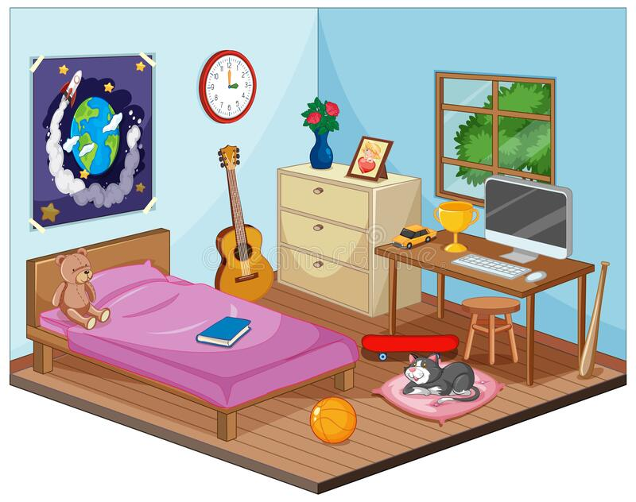

The computer is ----------------------------------- the desk.
The table is ------------------------- the window.
The book is ------------------the bed.
The poster is ---------------- the bed.
The vase is -------------------- the cupboard.

6. Make questions for underlined words. Zeptej se na podtržená slova.
1. Pamela has got a sister. ……………………………………………………………………………………..
2. My father works in a hospital. …………………………………………………………………………………..
3. Yes, they are at home. ……………………………………………………………………………..
4. Lucy has got a new bag. ……………………………………………………………………………
5. The tennis match starts at 4 o´clock. …………………………………………………………………….
6. Thomas is our friend. ……………………………………………………………………………
7. Joana’s grandma is eighty. ………………………………………………………………………..

7. Put the words in the correct order . Seřaď slova správně za sebou.
1. speak / teacher / can / Our / Italian
2. Mr. / on / is / Black / football / watching / TV
3. half / go / I / past / to / nine / bed / at.
4. James / film / his / talking / about / is / favourite
5. computer / got / haven´t / parents / His / a

8. Use was or were in the blanks. Použij was / were.

1. It ---------------- very hot yesterday.
2. -------------- you hot yesterday?
3. Where ------------ you?
4. Why ----------------your brother sad yesterday?

Součástí testu je i poslechové cvičení v rozsahu učiva úrovně A 1.

