Sample test – vzorový test pro přijímací zkoušky do 6. třídy

1. Read the text and answer the questions. Přečti text a odpověz na otázky.
Simon lives in a flat in a large town. He hasn´t got any pets. He´s got one sister. His sister is called Luise. And she works in a bank. The flat has got three bedrooms, a large living room, a kitchen and a bathroom but it hasn´t got a garden. Simon´s cousin is called Joanna and she lives in a large house in the country. She´s got a brother called Michael. Michael is a student. He lives in London. Joanna has got two cats and a dog. Her parents´ house has got four bedrooms, a living room, a dining room, a kitchen and two bathrooms. It´s got a large garden outside.
a) Does Simon have any pets ?
b) Are there four bedrooms in his flat?
c) Where does Joanna live ?
d) What is Joana’s brother’s name ?
e) Does Michael live in Leeds ?
f) Is there a dining room in parent’s house?

2. Choose the correct word. Vyber správné slovo.
1. Sara is a good basketball player. This is …………. racket
a) she´s b) her c) hers d) his
2. Do you like my new bag? …………………. colour is black.
a) It b) It´s c) It is d) Its
3. The snake ………………….. legs. It lives in a box.
a) have got b) has got c) hasn´t got d) haven´t got
4) Wait! We …………………………. a film on TV at the moment.
a) are watching b) watching c) watch d) is watching

3.
Write the time. Napiš spávně čas.
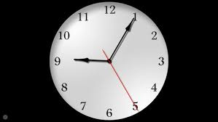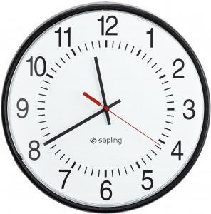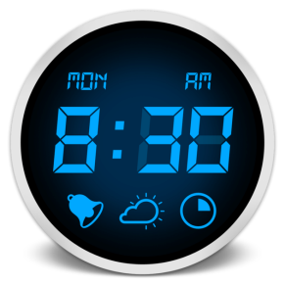

4. Put the words in the correct order . Seřaď slova správně za sebou.
1. speak / teacher / can / Our / Italian
2. Mr. / on / is / Black / football / watching / TV.
3. half / go / I / past / to / nine / bed / at.
4. James / film / his / talking / about / is / favourite.
5. computer / got / haven´t / parents / His / a

5. Fill in the preposition. Doplň správnou předložku.
The school is ……………………… the market. Carl is sitting ………………………. Jane and Alex. There is your car
……………………… the restaurant. Their dog is sleeping …………………… the table. Is there a toy shop…………………….
the High Street?

6. Make questions for underlined words. Zeptej se na podtržená slova.
1. Mary has got a sister. ……………………………………………………………………………………..
2. My mother works in a hospital. …………………………………………………………………………………..
3. Yes, they are at home. ……………………………………………………………………………..
4. joe has a new bag. ……………………………………………………………………………
5. The football match starts at 4 o´clock. …………………………………………………………………….
6. Ronald is our friend. ……………………………………………………………………………
7. Joana’s grandma is sixty. ………………………………………………………………………..

Součástí testu je i poslechové cvičení v rozsahu učiva úrovně A 1.

